|  |  |  |  |  |  |
| --- | --- | --- | --- | --- | --- |
| **lamapengobatan** | | | | | |
|  | | Frequency | Percent | Valid Percent | Cumulative Percent |
| Valid | 1 | 4 | 20,0 | 20,0 | 20,0 |
| 2 | 4 | 20,0 | 20,0 | 40,0 |
| 3 | 3 | 15,0 | 15,0 | 55,0 |
| 4 | 1 | 5,0 | 5,0 | 60,0 |
| 5 | 6 | 30,0 | 30,0 | 90,0 |
| 6 | 1 | 5,0 | 5,0 | 95,0 |
| 7 | 1 | 5,0 | 5,0 | 100,0 |
| Total | 20 | 100,0 | 100,0 |  |

LAMPIRAN 10

|  |  |  |  |  |  |
| --- | --- | --- | --- | --- | --- |
| **klasifikasipx** | | | | | |
|  | | Frequency | Percent | Valid Percent | Cumulative Percent |
| Valid | baru | 17 | 85,0 | 85,0 | 85,0 |
| lama | 3 | 15,0 | 15,0 | 100,0 |
| Total | 20 | 100,0 | 100,0 |  |

|  |  |  |  |  |  |
| --- | --- | --- | --- | --- | --- |
| **jeniskelamin** | | | | | |
|  | | Frequency | Percent | Valid Percent | Cumulative Percent |
| Valid | laki-laki | 9 | 45,0 | 45,0 | 45,0 |
| wanita | 11 | 55,0 | 55,0 | 100,0 |
| Total | 20 | 100,0 | 100,0 |  |

|  |  |  |  |  |  |
| --- | --- | --- | --- | --- | --- |
| **usia** | | | | | |
|  | | Frequency | Percent | Valid Percent | Cumulative Percent |
| Valid | 17-25 | 2 | 10,0 | 10,0 | 10,0 |
| 26-35 | 4 | 20,0 | 20,0 | 30,0 |
| 36-45 | 8 | 40,0 | 40,0 | 70,0 |
| 46-55 | 2 | 10,0 | 10,0 | 80,0 |
| 56-65 | 3 | 15,0 | 15,0 | 95,0 |
| >65 | 1 | 5,0 | 5,0 | 100,0 |
| Total | 20 | 100,0 | 100,0 |  |

|  |  |  |  |  |  |
| --- | --- | --- | --- | --- | --- |
| **pendidikan** | | | | | |
|  | | Frequency | Percent | Valid Percent | Cumulative Percent |
| Valid | SD | 4 | 20,0 | 20,0 | 20,0 |
| SMP | 5 | 25,0 | 25,0 | 45,0 |
| SMA | 8 | 40,0 | 40,0 | 85,0 |
| PT | 3 | 15,0 | 15,0 | 100,0 |
| Total | 20 | 100,0 | 100,0 |  |

|  |  |  |  |  |  |
| --- | --- | --- | --- | --- | --- |
| **pekerjaan** | | | | | |
|  | | Frequency | Percent | Valid Percent | Cumulative Percent |
| Valid | petani | 2 | 10,0 | 10,0 | 10,0 |
| wiraswasta | 4 | 20,0 | 20,0 | 30,0 |
| swasta | 8 | 40,0 | 40,0 | 70,0 |
| PNS | 1 | 5,0 | 5,0 | 75,0 |
| ibu rumah tangga | 2 | 10,0 | 10,0 | 85,0 |
| pelajar | 1 | 5,0 | 5,0 | 90,0 |
| tidakbekerja | 2 | 10,0 | 10,0 | 100,0 |
| Total | 20 | 100,0 | 100,0 |  |

|  |  |  |  |  |
| --- | --- | --- | --- | --- |
| LAMPIRAN 11  **pengetahuansebelum * pengetahuansetelah Crosstabulation** | | | | |
| Count | | | | |
|  | | pengetahuansetelah | | Total |
| baik | cukup |
| pengetahuansebelum | baik | 2 | 0 | 2 |
| cukup | 5 | 1 | 6 |
| kurang | 6 | 6 | 12 |
| Total | | 13 | 7 | 20 |

|  |  |  |  |  |  |
| --- | --- | --- | --- | --- | --- |
| **sikapsebelum * sikapsetelah Crosstabulation** | | | | | |
| Count | | | | | |
|  | | sikapsetelah | | | Total |
| baik sekali | baik | cukup |
| sikapsebelum | baik | 1 | 1 | 0 | 2 |
| cukup | 1 | 5 | 0 | 6 |
| kurang | 0 | 6 | 4 | 10 |
| kurang sekali | 0 | 0 | 2 | 2 |
| Total | | 2 | 12 | 6 | 20 |

|  |  |  |  |  |  |
| --- | --- | --- | --- | --- | --- |
| **usia * pengetahuansebelum Crosstabulation** | | | | | |
| Count | | | | | |
|  | | pengetahuansebelum | | | Total |
| baik | cukup | kurang |
| usia | 17-25 | 0 | 1 | 1 | 2 |
| 26-35 | 1 | 2 | 1 | 4 |
| 36-45 | 1 | 2 | 5 | 8 |
| 46-55 | 0 | 1 | 1 | 2 |
| 56-65 | 0 | 0 | 3 | 3 |
| >65 | 0 | 0 | 1 | 1 |
| Total | | 2 | 6 | 12 | 20 |

|  |  |  |  |  |
| --- | --- | --- | --- | --- |
| **usia * pengetahuansetelah Crosstabulation** | | | | |
| Count | | | | |
|  | | pengetahuansetelah | | Total |
| baik | cukup |
| usia | 17-25 | 2 | 0 | 2 |
| 26-35 | 4 | 0 | 4 |
| 36-45 | 6 | 2 | 8 |
| 46-55 | 0 | 2 | 2 |
| 56-65 | 1 | 2 | 3 |
| >65 | 0 | 1 | 1 |
| Total | | 13 | 7 | 20 |

|  |  |  |  |  |  |
| --- | --- | --- | --- | --- | --- |
| **pendidikan * pengetahuansebelum Crosstabulation** | | | | | |
| Count | | | | | |
|  | | pengetahuansebelum | | | Total |
| baik | cukup | kurang |
| pendidikan | SD | 0 | 0 | 4 | 4 |
| SMP | 0 | 1 | 4 | 5 |
| SMA | 1 | 4 | 3 | 8 |
| PT | 1 | 1 | 1 | 3 |
| Total | | 2 | 6 | 12 | 20 |

|  |  |  |  |  |
| --- | --- | --- | --- | --- |
| **pendidikan * pengetahuansetelah Crosstabulation** | | | | |
| Count | | | | |
|  | | pengetahuansetelah | | Total |
| baik | cukup |
| pendidikan | SD | 1 | 3 | 4 |
| SMP | 1 | 4 | 5 |
| SMA | 8 | 0 | 8 |
| PT | 3 | 0 | 3 |
| Total | | 13 | 7 | 20 |

|  |  |  |  |  |  |  |  |  |  |  |  |  |  |  |  |
| --- | --- | --- | --- | --- | --- | --- | --- | --- | --- | --- | --- | --- | --- | --- | --- |
| **pekerjaan * pengetahuansebelum Crosstabulation** | | | | | | | | | | | | | | | |
| Count | | | | | | | | | | | | | | | |
|  | | | | | | pengetahuansebelum | | | | | | | | Total | |
| baik | | | cukup | | | kurang | |
| pekerjaan | | petani | | | | 0 | | | 0 | | | 2 | | 2 | |
| wiraswasta | | | | 1 | | | 1 | | | 2 | | 4 | |
| swasta | | | | 1 | | | 3 | | | 4 | | 8 | |
| PNS | | | | 0 | | | 1 | | | 0 | | 1 | |
| ibu rumah tangga | | | | 0 | | | 0 | | | 2 | | 2 | |
| pelajar | | | | 0 | | | 1 | | | 0 | | 1 | |
| tidakbekerja | | | | 0 | | | 0 | | | 2 | | 2 | |
| Total | | | | | | 2 | | | 6 | | | 12 | | 20 | |
| |  |  |  |  |  | | --- | --- | --- | --- | --- | | **pekerjaan * pengetahuansetelah Crosstabulation** | | | | | | Count | | | | | |  | | pengetahuansetelah | | Total | | baik | cukup | | pekerjaan | petani | 0 | 2 | 2 | | wiraswasta | 3 | 1 | 4 | | swasta | 5 | 3 | 8 | | PNS | 1 | 0 | 1 | | ibu rumah tangga | 2 | 0 | 2 | | pelajar | 1 | 0 | 1 | | tidakbekerja | 1 | 1 | 2 | | Total | | 13 | 7 | 20 |   **Usia * sikapsebelum Crosstabulation** | | | | | | | | | | | | | | | | |
| Count | | | | | | | | | | | | | | | | |
|  | | | sikapsebelum | | | | | | | | | | | | Total | |
| baik | cukup | | | kurang | | | kurang sekali | | | | |
| usia | 17-25 | | 0 | 1 | | | 1 | | | 0 | | | | | 2 | |
| 26-35 | | 0 | 2 | | | 2 | | | 0 | | | | | 4 | |
| 36-45 | | 2 | 2 | | | 4 | | | 0 | | | | | 8 | |
| 46-55 | | 0 | 0 | | | 2 | | | 0 | | | | | 2 | |
| 56-65 | | 0 | 1 | | | 0 | | | 2 | | | | | 3 | |
| >65 | | 0 | 0 | | | 1 | | | 0 | | | | | 1 | |
| Total | | | 2 | 6 | | | 10 | | | 2 | | | | | 20 | |
| **usia * sikapsetelah Crosstabulation** | | | | | | | | | | | | |
| Count | | | | | | | | | | | | |
|  | | | sikapsetelah | | | | | | | | Total | |
| baik sekali | | baik | | | cukup | | |
| usia | 17-25 | | 0 | | 1 | | | 1 | | | 2 | |
| 26-35 | | 1 | | 2 | | | 1 | | | 4 | |
| 36-45 | | 1 | | 6 | | | 1 | | | 8 | |
| 46-55 | | 0 | | 1 | | | 1 | | | 2 | |
| 56-65 | | 0 | | 1 | | | 2 | | | 3 | |
| >65 | | 0 | | 1 | | | 0 | | | 1 | |
| Total | | | 2 | | 12 | | | 6 | | | 20 | |



|  |  |  |  |  |  |  |  |  |  |  |
| --- | --- | --- | --- | --- | --- | --- | --- | --- | --- | --- |
| **pekerjaan * sikapsebelum Crosstabulation** | | | | | | | | | | |
| Count | | | | | | | | | | |
|  | | sikapsebelum | | | | | | | | Total |
| baik | cukup | | kurang | | kurang sekali | | |
| pekerjaan | petani | 0 | 0 | | 1 | | 1 | | | 2 |
| wiraswasta | 0 | 0 | | 3 | | 1 | | | 4 |
| swasta | 2 | 3 | | 3 | | 0 | | | 8 |
| PNS | 0 | 1 | | 0 | | 0 | | | 1 |
| ibu rumah tangga | 0 | 1 | | 1 | | 0 | | | 2 |
| pelajar | 0 | 0 | | 1 | | 0 | | | 1 |
| tidakbekerja | 0 | 1 | | 1 | | 0 | | | 2 |
| Total | | 2 | 6 | | 10 | | 2 | | | 20 |
| **pekerjaan * sikapsetelah Crosstabulation** | | | | | | | | |
| Count | | | | | | | | |
|  | | sikapsetelah | | | | | | Total |
| baik sekali | | baik | | cukup | |
| pekerjaan | petani | 0 | | 0 | | 2 | | 2 |
| wiraswasta | 0 | | 2 | | 2 | | 4 |
| swasta | 1 | | 6 | | 1 | | 8 |
| PNS | 1 | | 0 | | 0 | | 1 |
| ibu rumah tangga | 0 | | 2 | | 0 | | 2 |
| pelajar | 0 | | 0 | | 1 | | 1 |
| tidakbekerja | 0 | | 2 | | 0 | | 2 |
| Total | | 2 | | 12 | | 6 | | 20 |

|  |  |  |  |  |  |  |
| --- | --- | --- | --- | --- | --- | --- |
| **Tests of Normality** | | | | | | |
|  | Kolmogorov-Smirnova | | | Shapiro-Wilk | | |
| Statistic | df | Sig. | Statistic | df | Sig. |
| pengetahuanpre | ,141 | 20 | ,200* | ,965 | 20 | ,639 |
| *. This is a lower bound of the true significance. | | | | | | |
| a. Lilliefors Significance Correction | | | | | | |

LAMPIRAN 12

|  |  |  |  |  |  |
| --- | --- | --- | --- | --- | --- |
| **Paired Samples Statistics** | | | | | |
|  | | Mean | N | Std. Deviation | Std. Error Mean |
| Pair 1 | pengetahuanpre | 8,20 | 20 | 1,963 | ,439 |
| pengetahuanpost | 12,25 | 20 | 2,099 | ,469 |

|  |  |  |  |  |
| --- | --- | --- | --- | --- |
| **Paired Samples Correlations** | | | | |
|  | | N | Correlation | Sig. |
| Pair 1 | pengetahuanpre & pengetahuanpost | 20 | ,779 | ,000 |

|  |  |  |  |  |  |  |  |  |  |  |
| --- | --- | --- | --- | --- | --- | --- | --- | --- | --- | --- |
| **Paired Samples Test** | | | | | | | | | | |
|  | | Paired Differences | | | | | t | df | Sig. (2-tailed) |
| Mean | Std. Deviation | Std. Error Mean | 95% Confidence Interval of the Difference | |
| Lower | Upper |
| Pair 1 | pengetahuanpre - pengetahuanpost | -4,050 | 1,356 | ,303 | -4,685 | -3,415 | -13,354 | 19 | ,000 |

|  |  |  |  |  |  |  |
| --- | --- | --- | --- | --- | --- | --- |
| **Tests of Normality** | | | | | | |
|  | Kolmogorov-Smirnova | | | Shapiro-Wilk | | |
| Statistic | df | Sig. | Statistic | df | Sig. |
| sikappre | ,116 | 20 | ,200* | ,975 | 20 | ,846 |
| *. This is a lower bound of the true significance. | | | | | | |
| a. Lilliefors Significance Correction | | | | | | |

|  |  |  |  |  |  |
| --- | --- | --- | --- | --- | --- |
| **Paired Samples Statistics** | | | | | |
|  | | Mean | N | Std. Deviation | Std. Error Mean |
| Pair 1 | sikappre | 30,35 | 20 | 6,393 | 1,430 |
| sikappost | 43,65 | 20 | 6,556 | 1,466 |

|  |  |  |  |  |
| --- | --- | --- | --- | --- |
| **Paired Samples Correlations** | | | | |
|  | | N | Correlation | Sig. |
| Pair 1 | sikappre & sikappost | 20 | ,848 | ,000 |

|  |  |  |  |  |  |  |  |  |  |
| --- | --- | --- | --- | --- | --- | --- | --- | --- | --- |
| **Paired Samples Test** | | | | | | | | | |
|  | | Paired Differences | | | | | t | df | Sig. (2-tailed) |
| Mean | Std. Deviation | Std. Error Mean | 95% Confidence Interval of the Difference | |
| Lower | Upper |
| Pair 1 | sikappre - sikappost | -13,300 | 3,570 | ,798 | -14,971 | -11,629 | -16,659 | 19 | ,000 |

**DOKUMENTASI PELAKSANAAN HEALTH BELIEF MODEL**

LAMPIRAN 13

Wawancara HBM Responden tentang pencegahan penularan TB

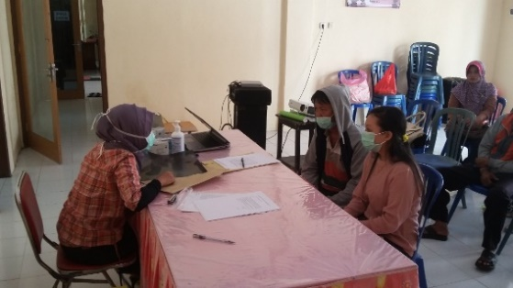

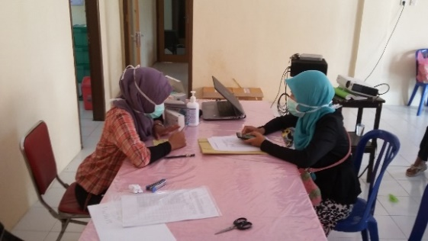

Wawancara HBM melalui kunjungan rumah

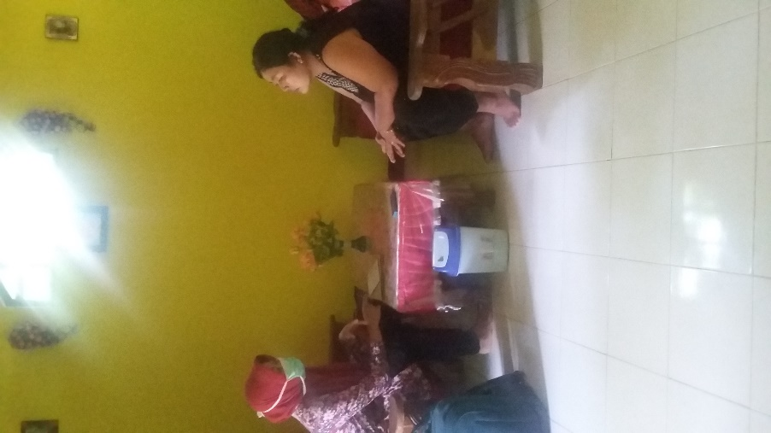

Pengisian Kuesioner Pre test

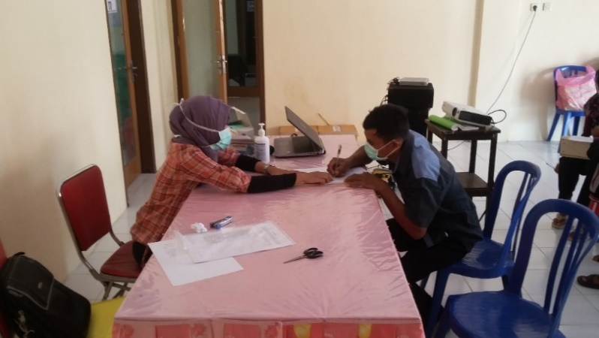

**Pendidikan kesehatan pencegahan penularan tuberculosis**

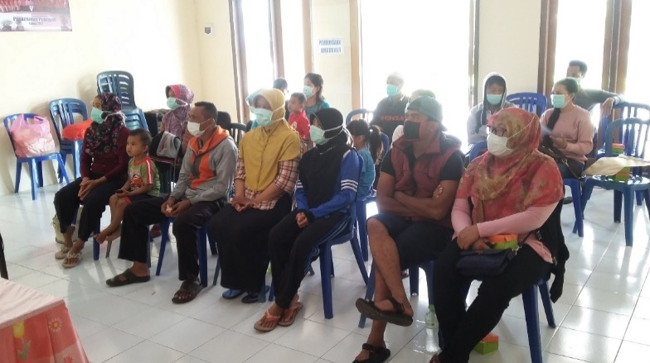

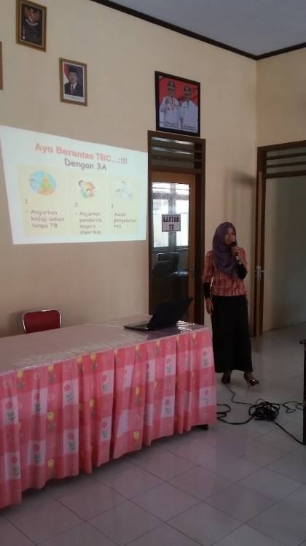

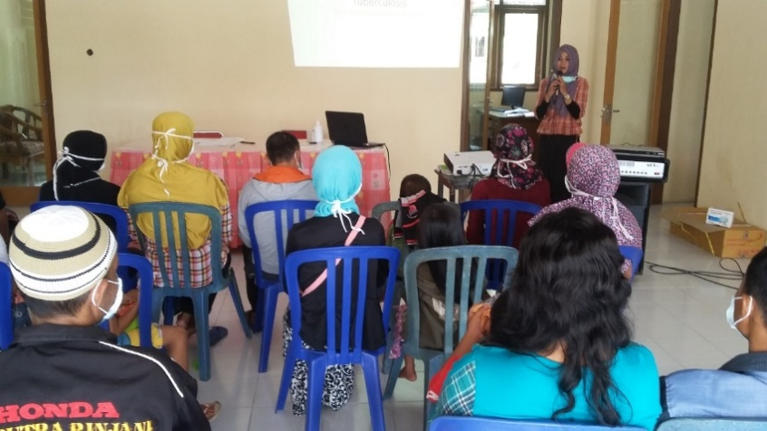

Pengisisan Kuesioner Post Test

